Screenshots
(Prompt History : Claude & ChatGPT)

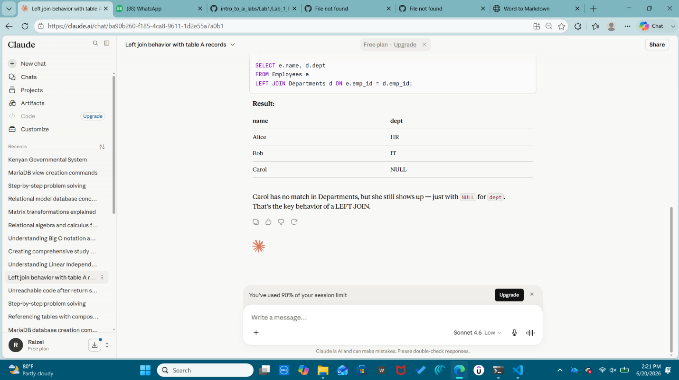
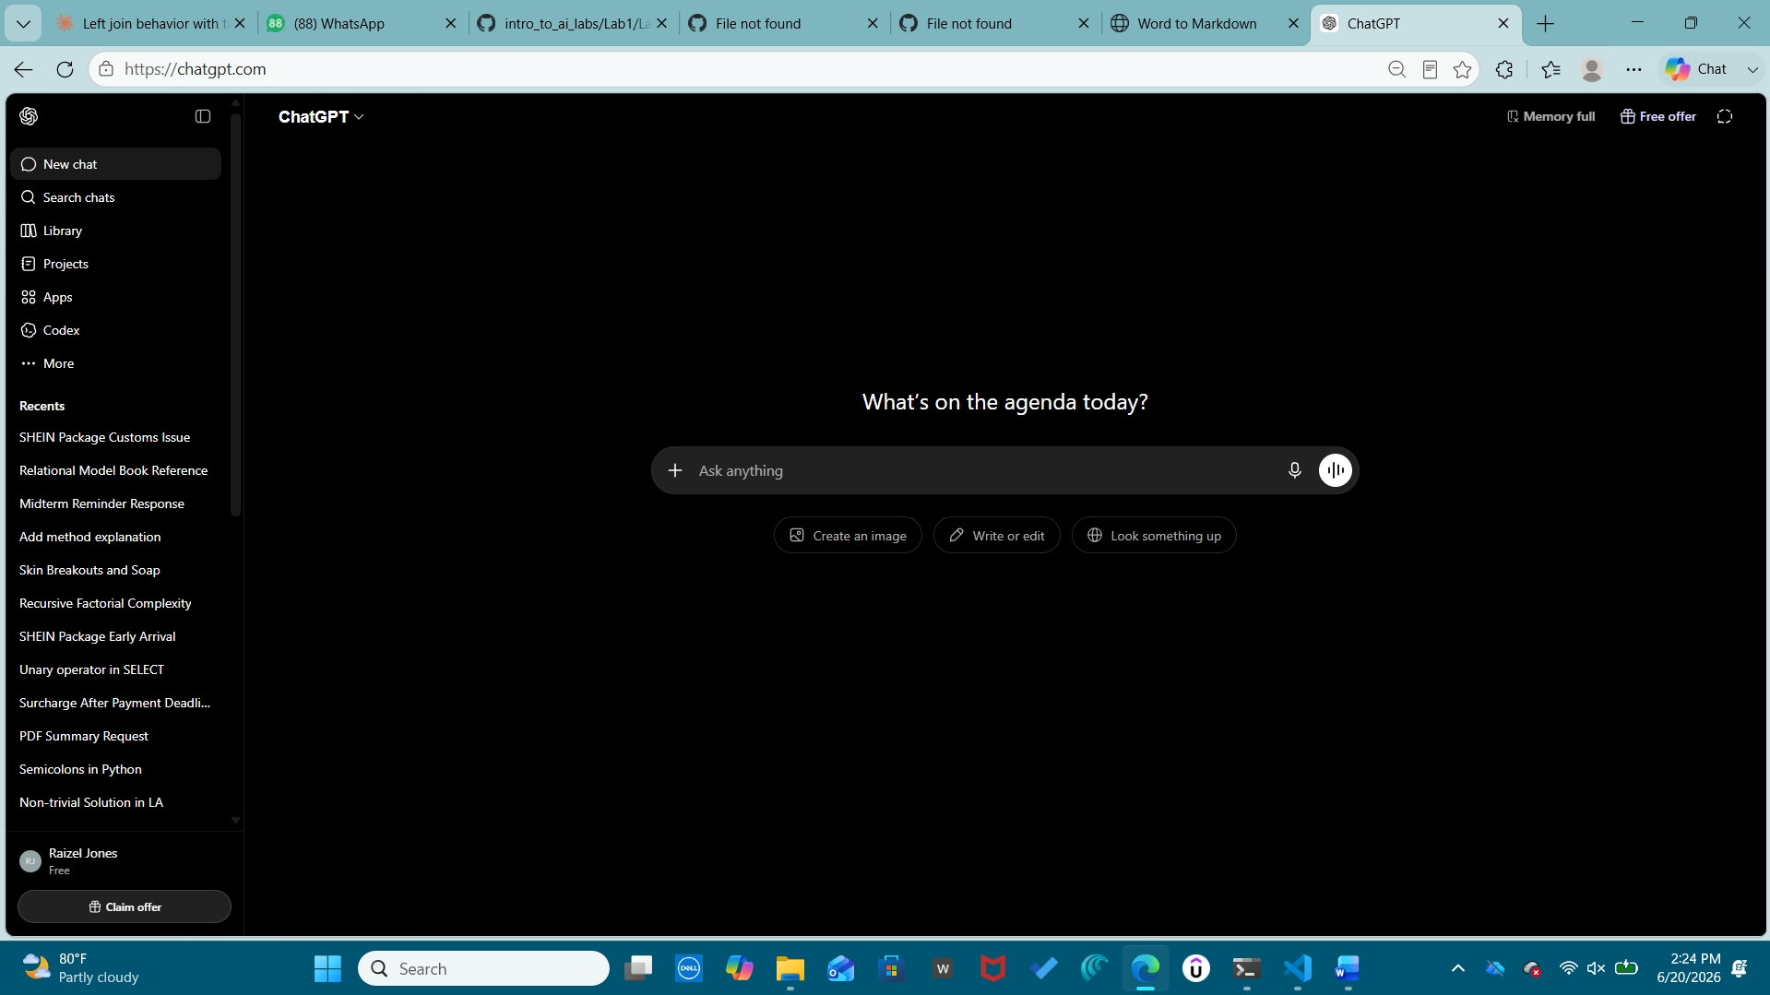
Chat Links
https://claude.ai/share/52142ede-4790-4849-9838-b8eb9a11c906
https://gemini.google.com/share/3ddfd1dd4a5c

